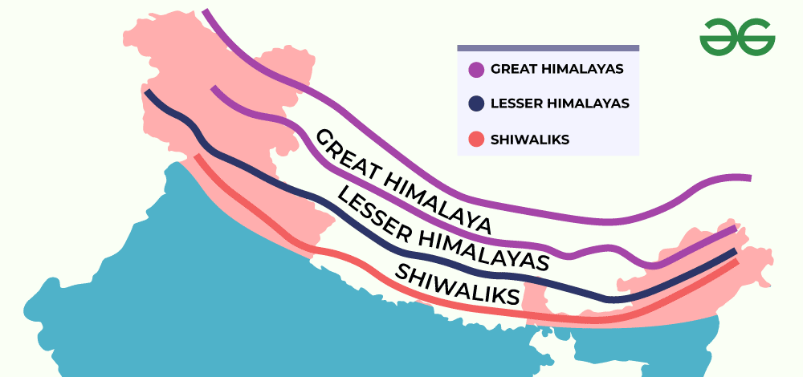

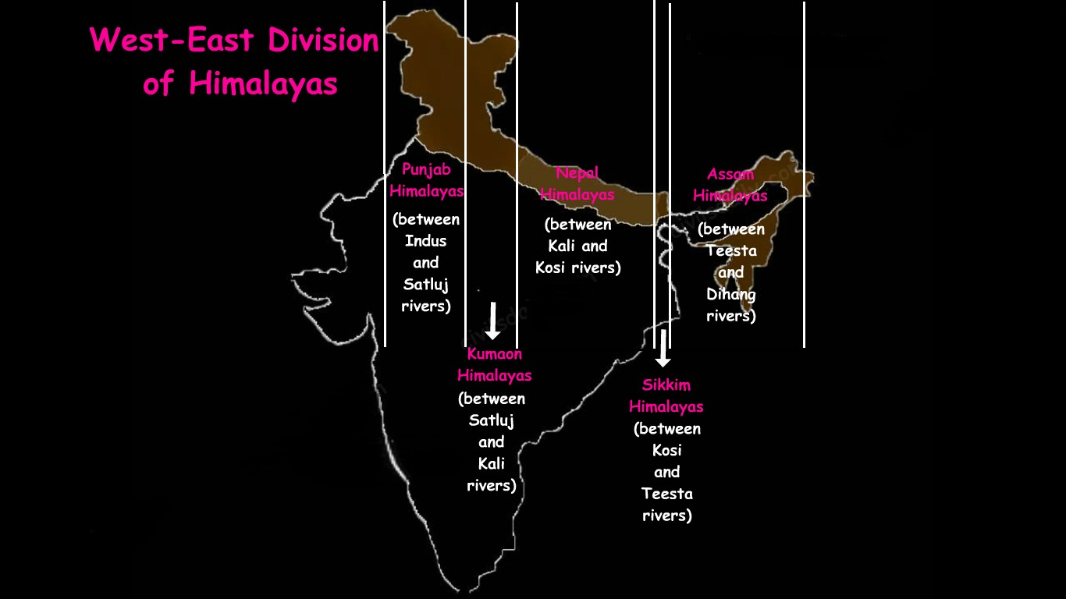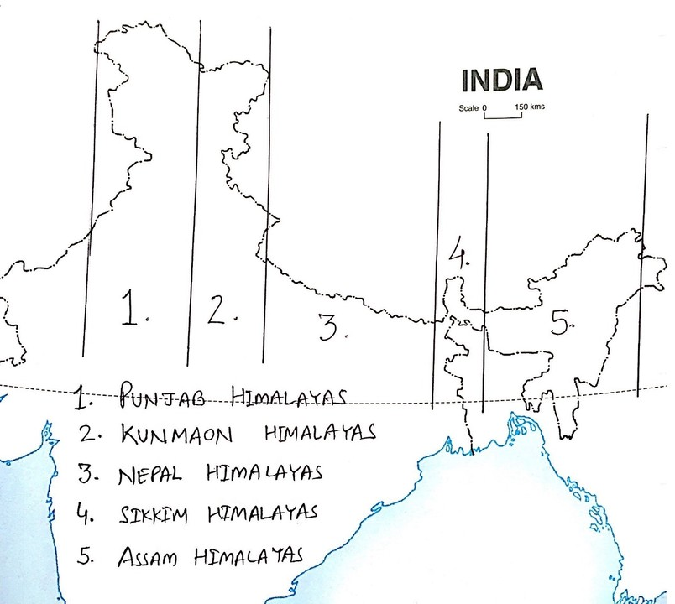

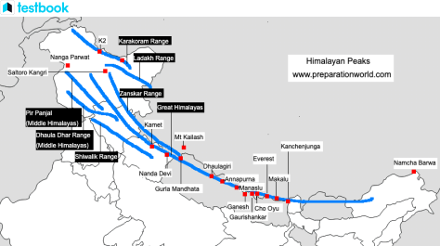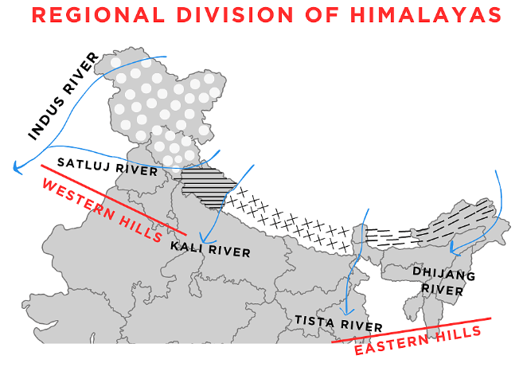

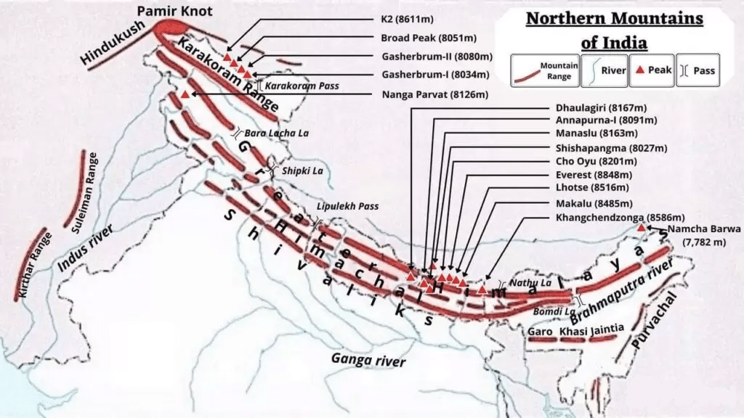

Name of Pass | Strategic importance | Location
Aghil La. | Connects Ladakh with Xinjiang Province | situated north of Mt. K2  (Godwin Austen).
Karakoram | The highest pass of India. | situated in the U.T of Ladakh.
Burzil | connects Srinagar and Gilgit. | situated in the Greater Himalayas  of Ladakh Union Territory.
Zoji La | Srinagar-Leh highway passes through it. | situated in the Zaskar Range in  Ladakh U.T.
Pir Panjal | connects Kullu valley with  Lahaul and Spiti valley. | situated in the Pir Panjal range  of Himalayas.
Banihal | The Jawahar Tunnel passes through it. | situated in the Ladakh region.
Shipki La | the road from Shimla to Tibet passes  through it. | situated in the Zaskar Range in  Himachal Pradesh.
Bara Lacha La | a road connecting Mandi and  Leh passes through it. | situated in the Zaskar Range in  Himachal Pradesh.
Mana | connects Uttrakhand to Tibet | situated in the Kumaun range in  Uttrakhand.
Niti | a road connecting to Mansarovar and  Kailash valley passes through it | situated at Indo-China border in  the Kumaun range in Uttarakhand.

